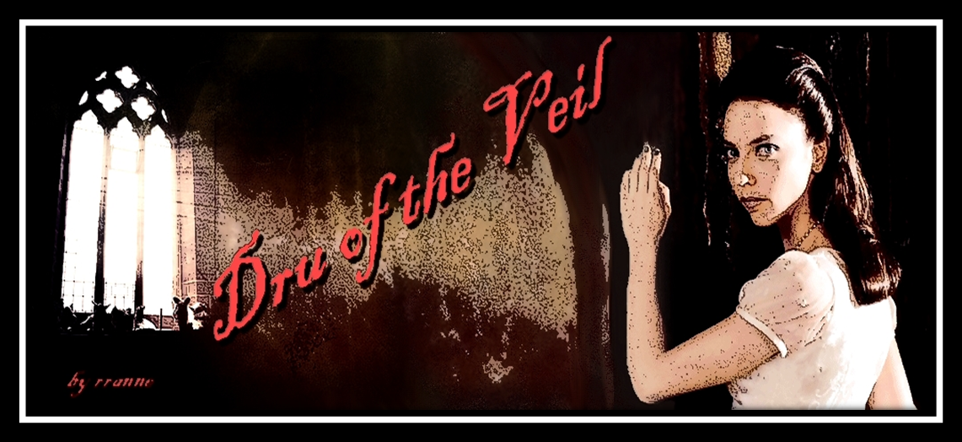
I
Abbey of St. Brigid, Glastonbury Parish, 11 April, 1841.

“There, there, dear child,” The Reverend Mother Igraine said as she wrung out the cloth again. The water already stained the darkest crimson with the girl’s blood. They had found her at Laudes, when they came to perform their morning office and prayers; they found her huddled and whimpering at the foot of the statue of their Blessed Lady of the Veil.
“He will not find you here.”
“…always find me,” the girl whispered barely audible. It was the first thing Igraine had been able to discern of her mumblings.
“What’s that you say, child,” she said dabbing gently at the wounds and blood caked on the girls neck, her face now free of the dirt and blood that had obscured it; it was a pretty face, though the bruises were starting to ripen and swell and the cuts and gashes were deep enough to mar it permanently if care was not taken for them to knit well.
“He said he would always find me,” she murmured, the puffiness of her jaw keeping her words to the barest whisper, “he…he said that there is no place I can hide, no place, none….I can’t hide from Angel.”
“Was no angel that did this,” the older woman said, wiping the wounds on the girl’s slender neck; two punctures beneath the bruises from large and powerful hands on each side. They mirrored the ones Igraine could see on her breasts between the remaining shreds of tattered cloth that had once been a respectable frock, “…far from it.”
“No but, it was ….Angel, a beautiful angel.”
Miriam came with a bucket of water to freshen the basin and a stack of clean cloths; she offered a dipper of the restorative liquid from the abbeys springs to the girl who took it with unsteady hands.
“Spit first, child, then drink,” said Igraine who presented the wash basin as spittoon before she rose to dump it. Igraine was pleased that no teeth came out, only blood tinged spittle and pus …and Goddess only knows what else, from the looks of her the monster was truly a deviant; she could wait until after the child had recovered in some degree to check for loose and damaged teeth.
Miriam refilled the dipper again and offered it to the girl; she drank deep, lifting the dipper to help the cool water flow easier down her bruised and parched throat. Miriam saw the ripped puncture wounds on her delicate battered neck as well as those on the alabaster skin of her breasts, blood slowly trickled from the deep claw-like scratches that surrounded the lesions and extended across her breasts up to her neck and down onto her torso, the cleansing having dissolved the scabs that had knit the scrapes together. Miriam made the sign of the cross in deference to the Christian God of the Abbey and silently mouthed the healing blessing of the Mother; she kept her head bowed until Igraine returned with the empty washbasin lest either the girl or Igraine see her breaking her vows.
Igraine returned and knelt with the basin. “Suppose we will need another refill or two before tis all done,” Igraine said as Miriam poured the contents of the bucket in to the basin. Miriam gave the slight quick nod that was the allowed signal of acknowledgement from one avowed as she.
“But before,” the elder woman continued, “… fetch my sewing scissors and thread, the boiled silk not the wool, and some of the new cheesecloth from the stores, both course and fine, and Father Padric’s best bottle from the empty herring barrel behind the rectory, and see what is keeping Aubreigh with the salves.”
Miriam bowed in respect of the Reverend Mother Superior of her Order and obeyed in silence.
Igraine dipped the cloth in the fresh basin, wrung it slightly and turned her attentions once more to the girl still shivering and whimpering at the feet of the statue.
“What is your name child?” She asked, her gaze being drawn inexplicably from her charge to the face of the Lady.
“Dru…Drucilla,” the girl answered meekly.
Igraine imagined she saw tears from the eyes of the icon on its cheeks as the rays of the morning sun illuminated its carved wooden countenance.
~

II

She woke with a start, startled by her own screams, and rapidly sat bolt upright in the bed. That was more a mistake than she could have imagined as her head lightened to the point of near fainting from the sudden rise from the pillow and the harshness of the light when she opened her eyes sent jagged bolts of lightning back through her brain.
Her ribs hurt terribly when she tried to breathe and there was no part of her body that did not ache. Laying back down eased neither the aches nor the sickness the accompanied them.
She looked about the room but did not recognize anything of it, and there was a small, strange, dark complected woman sitting near the brazier apparently working on some stitching; she looked like one of the faerie-folk her grand-mummy used to tell tales of when she was little.
“I screamed,” she said, her voice raw and rasping, like gravel to her ears.
“I am sure you did, pity t’was no one there to hear,” the dark woman said, her quiet voice carrying across the room.
“O…” Dru tried to clear her throat, but only succeeded in causing it to hurt more, “…no, j-just now, I screamed. I’m sorry.”
“T’was only a dream and did not disturb me,” the slight woman said laying aside the stitching and rising to attend to one of the kettles on the brazier. “Ye’ve slept but a few hours,” she said, pouring steaming liquid from the smallest vessel into a pottery cup. Watching her come toward her, Dru could see she worn the habit of a nun, yet not the wimple, and the habit was at once the darkest blue and a warm forest green; not at all a colour she had seen worn by the sisters in either London or Cornwall.
She pulled herself up on the cot as best she could as the petite woman approached with the cup; it was not an easy task.
Sitting gingerly on the edge of the cot, the dark woman handed her the cup.
“Mother Igraine says you are to drink this,” the woman said waiting until she was sure the drink would not spill in Drucilla’s unsteady hands, “… then, when you are able, you are to have some bread and broth. I am Sister Meagg. I am to attend you until Sister Aubreigh returns; she has gone across the fen to collect the makings of a poultice for your wounds.”
Dru slowly raised the cup to her lips. She sipped and shivered at the liquid’s acridness and made a face that Meagg thought likely pained her as it strained the swelling and bruises.
“Tis a tincture of willow bark, drink it slowly, it does no good if it does not stay with you. You are called Drucilla?” She inquired. Drucilla nodded, still sipping at the tonic.
“Are you faring any better now than this morning, Drucilla?”
“Please, D-dru, not…” He had called her Drucilla while…she did not want to think of it. She turned away and snuffled quietly.
“Dru ‘t will be then,” Meagg said giving a gentle pat on the girl’s turned-to shoulder.
“I’m sorry,” she said timorously turning to face her with tears flowing freely down her cheeks stinging the scrapes there.
“No need to be,” Meagg answered.
“W-where am I,” Dru said trying to fight the dread that was hovering so near, “… what day is it?
“Presently, Meagg replied , rising to again attend the brazier,”… you are in the novitiate’s cell of the charter house of the Abbey of St Brigid, Glastonbury Parrish, Somerset, England and tis quarter past one Sunday afternoon, April eleventh, in the year of our Lord, 1841.”
“Glastonbury Abbey…” she whispered not sure how she came to be anywhere near there. She had been in Whitechapel, London, not a month ago.
“Not the famous one of old,” Meagg paused as if realizing that was, perhaps, untrue “…one of them though, I reckon. We are but a small order of twelve and Brigantine by affiliation.”
There had been many abbeys at Glastonbury, the largest of which had been Benedictine; now only ruins remained, neglected as many another discarded wives of Bath, the last abbot hanged in St Michael’s, the tower of the Tor, three hundred years ago.
All had been destroyed by fire by earthquake or the last, by ole King Henry’s hand. Grand-mummy always said the Tor would not permit anything impure upon it for long; Dru had not thought of it since she was a child, thinking on it now for whatever strange reason it was occupying her head, along with the mention of the old Abbeys, and the pleasant smell of the herbs strewn in the room, made her think that Grand Mummy had indeed been right, it was a living thing and would not tolerate evil upon it.
She shivered, as she did before one of her visions would come upon her, but none was forth coming; the moment passed without revealing anything.
Meagg had fetched the broth that had been warming in a ramekin on the brazier and some bread and a little of the abbey’s soft cheese for her. It was good thought her jaw hurt to chew with as her throat did to swallow.
She made another cup of the willow bark tea and bade her to drink it slowly over the course of the rest of the afternoon. Drucilla took a small sip to wash down the last of the bread and studied her surroundings again, with more attention this time.
The novitiate’s cell was little more than a converted animal lean-to up against the side of the charter house proper, its walls had been reinforced against the weather by several layers of added daub and wattle and its roof was much in need of re-thatching. Yet it was clean and smelled pleasantly of the herbs strewn as ward against the insects of the field that always seemed to take up residence in country dwellings such as this. The mix of chalky whitewash shading the walls and woad time-worn into the grain of the woodwork gave a bright and homey feel to the otherwise simple room.
They had replaced her shredded clothing with the soft chemise and the homespun overdress of a novitiate, fairer in colour than Meagg’s had been, hung on a hook nearby. The sheets smelled of the April breeze and though it was midafternoon she fell quickly onto an uneasy sleep.

